|  |
| --- |
| **D:\fcuc-logo.png** |
| **FACULTY OF ENGINEERING & COMPUTING** |

|  |  |  |
| --- | --- | --- |
| **Programme** | : | Bachelor of Software Engineering (Hons) |
| **Academic Year** | : | 2019 |
| **Module** | : | Business Intelligence |
| **Module Code** | : | CIS2016 |
| **Module Leader** | : | Kwan Lee |
| **Assignment Type** | : | Report |
| **Intake/Group** | : | Intake/Group |
| **Distribution Date** | : | Monday, 14 October 2019 |
| **Submission Date** | : | Tuesday, 3 December 2019 4:55 PM |

|  |  |  |
| --- | --- | --- |
| **Student Name** | **Student ID** | **Class Code** |
|  |  |  |

|  |
| --- |
| **Assignment Feedback Form** |
| Business Intelligence |

|  |  |  |
| --- | --- | --- |
| Criteria | Marks | Comments |
| Analysis the Problem faced by the Company | /5 |  |
| Discussion | /10 |  |
| Format Report | /5 |  |
|  | Total |  |

Marks:

|  |  |
| --- | --- |
| **General Comments:** | |
|  | |
| **Assessor’s Signature**: | **Date:** |
| **Name: Kwan Lee** | |

|  |  |  |  |  |  |  |  |
| --- | --- | --- | --- | --- | --- | --- | --- |
| **Section: Documentation**  **/20** | | **Excellent** | **Good** | **Satisfactory** | **Marginal** | **Poor** | **Comments** |
| **(Out of 5)** | Analysis the Problem faced by the Company |  |  |  |  |  |  |
| **(Out of 10)** | Discussion |  |  |  |  |  |  |
| **(Out of 5)** | Format Report |  |  |  |  |  |  |

|  |
| --- |
| **General Instructions** |
| Use the following format for the preparation of the *assignment submission*.   * Paper size : A4 * Margins: left = 1.5”, right, top and bottom = 1” * Font size : 12 , Times New Roman/Arial * Line spacing : 1.5 * Text alignment : Full Justify * Number all pages sequentially * Number all Figures and Tables sequentially and refer them in the text * Binding: **staple at top left corner** of assignment submission * Reference format: Harvard or IEEE |

|  |
| --- |
| **WARNING** |
| * + Assignments submitted after the due date will be considered late.   + Assignments submitted not later than two weeks after the due date will be marked, but the marks will be capped to a maximum of 20%.   + Assignments submitted later than two weeks will be marked, but carry zero mark.   + First City University College takes allegations of plagiarism very seriously. Submissions involving plagiarism will be marked, but given zero mark. Plagiarism is the attempt to pass off the work of another as your own. Information taken from the work of others should be acknowledged by reference to obviate the charge of copying.   + Collusion is an academic irregularity within the First City University College assessment regulations. Any student found colluding in the production of any assessment will be subject to an investigation with the imposition of any penalty deemed appropriate. Students must ensure they are familiar with the definition of collusion. |

1. **Assignment**

This is an individual assignment and it contributes **20%** of the assessment.

In this assignment, you are required to prepare case study report based on the given case study: Domino Pizza Case Study

This assignment consists of **TWO (2)** tasks as listed below:

***Task 1 –*** ***Analyse the Problem faced by the Company***

From the case study given, analyses what are the problems faced by the Domino Pizza.

***Task 2 – Discussion***

If you were the Business Intelligence (BI) analysis, in your own opinions:

1. Discuss how you can/should re-identify the cycle of BI analysis.
2. Discuss what type of analysis techniques (descriptive, predictive, and prescriptive) you will propose to address the problem?

S***ubmission Requirements***

1. Submit a soft copy and a hard copy of your report, following the general instructions described above.
2. Submit a copy of TurnItIn report.

Details of TurnItIn

Class Id : 22690225

Enrollment Key: 1234

1. Submit a copy of your report into GitHub repository.
2. Minimum number of report pages is 3, and maximum number of report pages is 10 pages (excluding the front cover, table of content pages and appendix).

# Case Study

Domino’s n Hot Soup After Filling Police Report Against It’s Own Customers

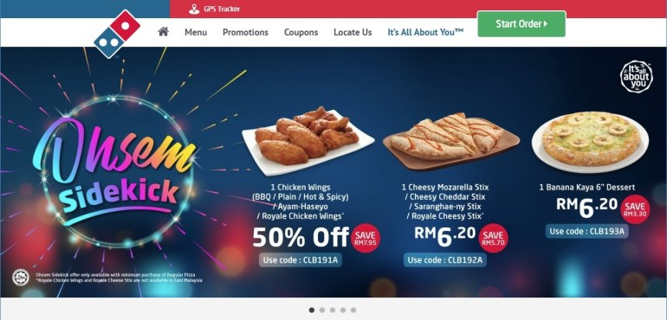

Popular pizza chain Domino’s has found itself embroiled in a social media storm this week after several of its online customers were called up by the Commercial Crimes Department of the Royal Malaysia Police (PDRM) for questioning after ordering their meals online.

Domino’s has since claimed that these customers were reported as they had ‘abused’ ‘unauthorized’ vouchers in their purchase. In what we can only call a ‘hastily’ released media statement earlier today, Domino’s made the following claim.

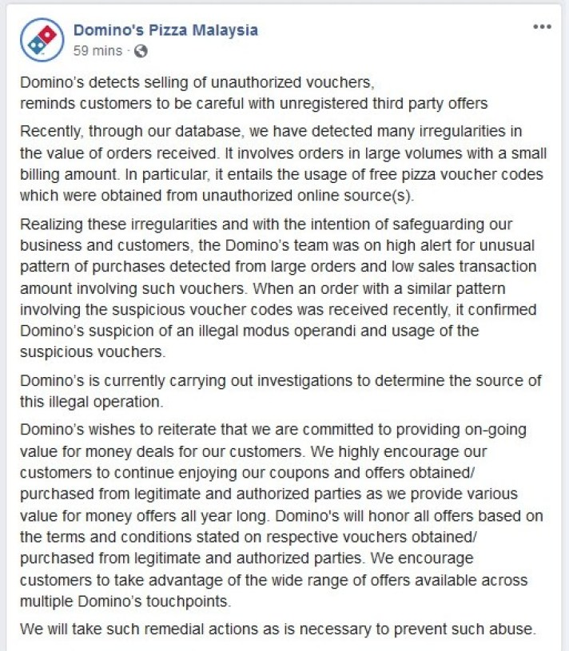*screengrab of Domino’s original Media Statement that was subsequently removed*

The above statement, which was published on their Facebook page, and sent out to local media outlets, was quickly taken down after it received severe backlash from their own followers. Sadly enough, for Domino’s – the Customers in this case actually had every right to feel aggrieved by their actions.

According to comments from one of the Customers who was questioned by the PDRM, as well as a copy of a counter police report that we have sighted – Domino’s are claiming that the customer had illegally ‘hacked’ the Domino’s online platform, and had utilized illegal voucher codes to purchase meals at a heavily discounted price.

While we’re not entirely sure how [legitimate coupon codes ended up on online shopping sites like Shopee](https://shopee.com.my/Kupon-Dominos-i.10719448.1896690295), it is complete and utterly unfair to blame any customer for using these codes as the codes still remain valid on Domino’s site. If the coupon codes were illegally obtained, Domino’s should be filing a report against the seller of the codes, and disabling these ‘unauthorized’ codes on their system. At time of writing, the above coupon codes are still listed for sale on the Shopee platform.

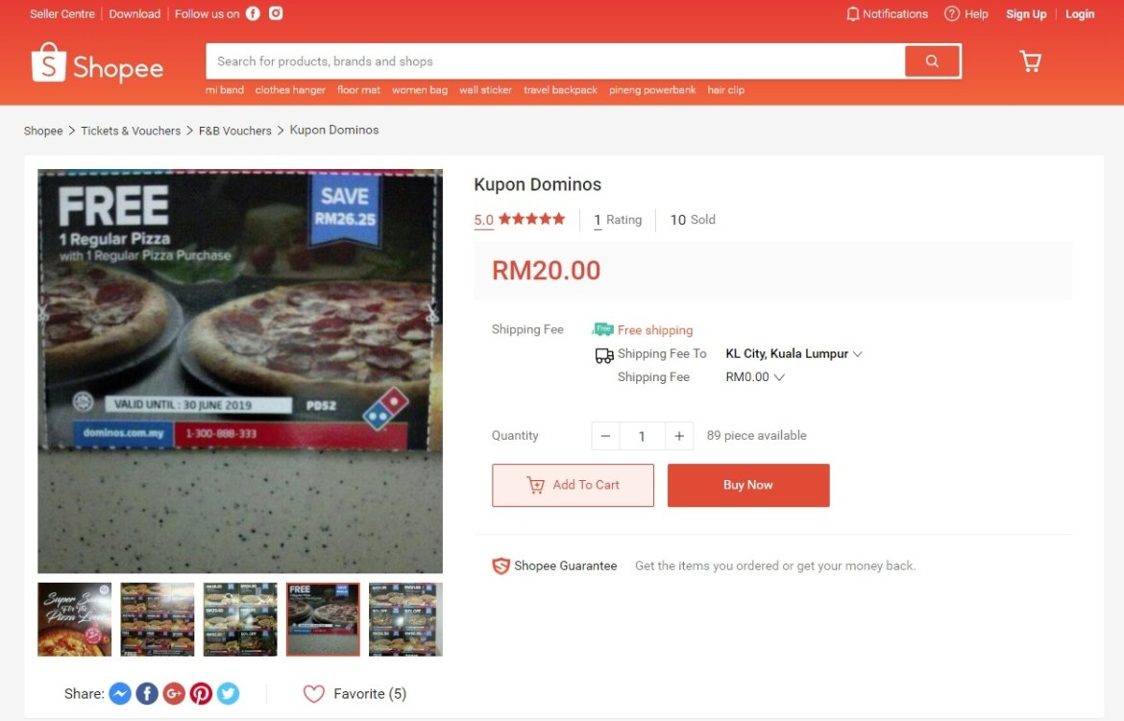

Domino’s via their original statement had put the blame of the irregularities on the order amounts solely on the coupon and free pizza codes. What they have failed to admit (or maybe even realize) is that there are fundamental logic flaws in their online ordering system that has been exploited long before they went on ‘high alert for unusual pattern of purchases’.

These known ‘flaws’ or ‘glitches’ in their system was never fixed (and still hasn’t been fixed at time of writing), and oddly enough worked both ways. Unsuspecting customers who were not aware of the glitches might end up paying more for their orders through odd combinations made during their order process, while other customers who noticed the flaws would have been able to easily exploit the glitch to gain a huge discount on their order.

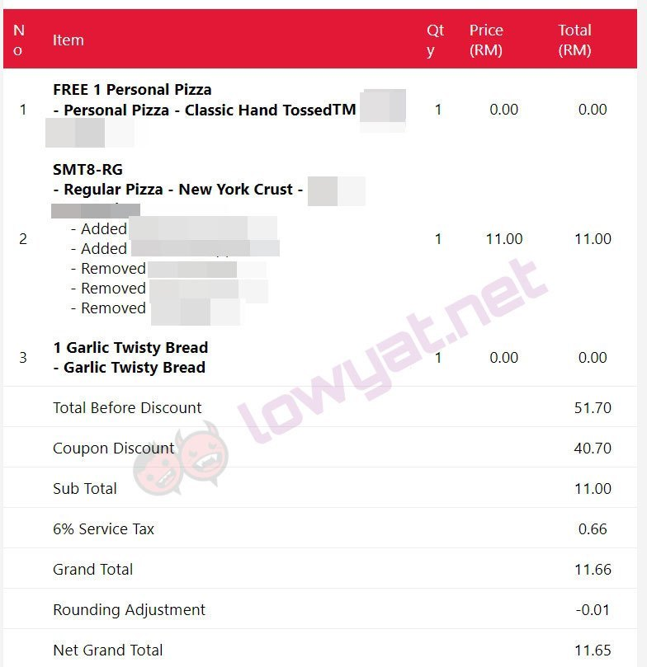*screenshot of checkout page after hefty discount – via Lowyat Forums*

Are you as an online consumer liable if you exploit these glitches in an online ordering system to your advantage? The short answer is probably no. During Amazon Prime Day Sale in July this year, [Amazon accidentally discounted high end camera gear – some costing close to USD13,000+ for a measly USD100](https://www.engadget.com/2019/07/18/amazon-prime-day-pricing-error-camera-gear/). Amazon acknowledged their mistake and honored all the purchases.  Domino’s did not (and still have not) corrected the obvious flaws in their system that is allowing this to happen. While some have cited the simple analogy of if a door is left open, stealing is still a crime – the difference here is that these customers have entered into a legitimate contract with Domino’s and paid the advertised price for their meal that has been agreed and accepted by Domino’s via their flawed system.

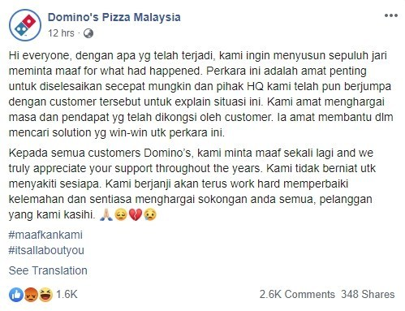

*updated ‘apology’ from the Domino’s team*

While Domino’s has every right to refuse service to these customers, and refund their money – there was absolutely no need for them to file a police report that caused their customers to be interrogated by police in a public place for their own incompetence and negligence in managing their online ordering system.

*Taken from https://www.lowyat.net/2019/195025/dominos-in-hot-soup-after-filing-police-report-against-its-own-customers/*

# Learning Outcomes

|  |  |
| --- | --- |
| **Learning Outcomes** | **Assessment Question** |
| 1. Explain the concepts and components of Business Intelligence; | Task 2 |
| 1. Evaluate the technologies that make up Business Intelligence; | - |
| 1. Describe the technological structure that makes up Business Intelligence systems | - |
| 1. Plan the implementation of Business Intelligence system. | - |

# Assessment Marking Criteria

|  |  |  |  |  |  |
| --- | --- | --- | --- | --- | --- |
| **Area of concern** | **Excellent** | **Good** | **Satisfactory** | **Marginal** | **Poor** |
| Identify the Problem faced by the Company (5%) | Excellent quality of problem identify. | Well quality of problem identify. | Average quality of problem identify. | Fairly quality of problem identify. | Low quality of problem identify. |
| Discussion  (10%) | Rich in content demonstrating, critical thinking insight, and analysis. | Substantial information that demonstrates thought, insight, and analysis has taken place | General competent comments but information is thin/limited | Basic statements with minimal analysis/insight expressed | Basic statements with no analysis/insight expressed |
| Format Report (5%) | Closely adheres to all formatting requirements.  Clear and concise. Good grammar and spelling. Clear structure. About the right length. Several references, done correctly. | Generally adheres to the specified formatting.  Clear and concise but some grammar/spelling errors. Un-numbered sections/ too informal in places/ too verbose. Some references/ some referencing errors. | Deviates from the formatting requirements.  English is generally: too informal/ not precise/ too glib. Structure not very clear. Possibly not enough info - too short. Hardly any references/ not done correctly. | Significantly deviates from the formatting requirements.  A lot of grammar errors. Not structured as per the spec. Vague and waffle style. No references. badly done references. | Guidelines /requirements of the formatting are largely ignored.  Illiterate. Unable to understand what is meant. |

***Task 1 –*** ***Analyse the Problem faced by the Company***

From the case study given, analyses what are the problems faced by the Domino Pizza.

From the case study given, the problems faced by the Domino Pizza are coupon validation. At the very beginning , Domino pizza company found out that the customers online purchased their product with large amount of quantities but the amount they pay are less then what they expect trough their database. Domino Pizza Company suspect that the customer were “hacked” into their online platform successfully and take advantage of the system.

Domino happen to report those customers that made that suspicious purchases to Royal Malaysia Police (PDRM).In that event, the customers are being interrogated by the police for the suspicious order that they made with Domino Pizza. After the investigation, Domino Pizza Company found out that those customer purchase pattern are alike to each other. All of them use the illegal coupons to make the online purchase at Domino online platform. Surprisingly most customer claim that they brought the coupons at third party seller such as e-commerce website ‘Shopee’.

The illegal coupons that sold on the e-commerce are at a reasonable price which allow the customer to purchase pizza more worth compare to the actual coupons or discounts that given by the Domino Pizza company .It is more beneficial for customer to use the unauthorized coupon compare to the normal coupon as a customer perspective. How the unauthorized third party get the coupon or discount is unknown.

The main problem is not only the unauthorized coupons that customers used, but as well the ‘flaws’ or ‘glitch’ that already existed in the ordering system way back before the case happened. For example the customers are allow to add different ingredients to the pizza and there is no additional charges on it. In such a way, customers are paying less that the actual amount they need to pay for the order. Although Domino Pizza Company notice the present of it but they never addresses the issues until now. This allow the customer to gain benefit from the systems.

***Task 2 – Discussion***

If you were the Business Intelligence (BI) analysis, in your own opinions:

a. Discuss how you can/should re-identify the cycle of BI analysis.

Analysis

Form the case study given. Two problems faced are by Domino Pizza company are invalid coupons validation and their ordering system. First, Domino Pizza Company found in some customer’s purchase their pizza with large amount but the amount they pay are less then what they expected. After investigation, they found out that customers can buy the illegal coupons online that sell by the unauthorized third party in e-commerce platform. Second, The “flaws” or “glitch” on their ordering system. Customers are allow to add different ingredients to the pizza and there is no any additional charges on the pizza. This allow the customer to skip the additional charge for the extra ingredients that they added.

Insight

From the analysis we know that the customer brought the illegal coupon from unauthorized third party in e-commerce website ‘shopee’. Furthermore, Domino Pizza system fail to check the validation for the coupons. Due to Domino Pizza Company’s system never check the coupon are valid or invalid, this allow unauthorized third party to take the advantage to fool the system with illegal coupon and profit from it.

For the ‘flaws’ or ‘glitch’ on Domino Pizza’s ordering system may cause by inefficiency algorithm. The logic of the algorithm to generate the price based on the selection additional ingredients might have overlook the business logic validation. This mean, system might not able to or skip the calculate part for the correct amount of the pizza when the additional ingredients has added in to the pizza.

Decision

For the illegal coupon, Domino Pizza Company can keep track their coupons code when they created it by storing the code in the database. This can prevent the coupons code fall onto other people hand. By doing this Domino can also easily identify whether that the coupons is illegal or not. Furthermore, Domino Pizza Company also can analyse the coupons pattern used by the customers that made the suspicious purchases. By analyse that coupons, Domino Pizza Company should be able to identify the pattern of the code that use by the customer. After analysis, Domino can also collaborate with search engine like google or Firefox to trace back the customer and find out customer brought the illegal coupon in which e-commerce website. By this means if Domino Pizza Company detect the same pattern of the coupon code they will know that is an illegal coupons get from the e-commerce platform.

For the ‘flaws’ or ‘glitch’ on Domino Pizza’s ordering system, Domino Pizza have to create and set the price for all the combination of pizza then store it in their database. This enable them to check the price of all the pizza even customer customise their pizza.

Evaluation

By validating the coupon the system should be able to detect the illegal coupons prevent the customer to further make the purchase.

The ‘flaws’ or ‘glitch’ will be correct after apply the decision. The additional charges will be accounted into the order price when customer make changes on the pizza.

b. Discuss what type of analysis techniques (descriptive, predictive, and prescriptive)

Predictive analysis techniques used the pass event or data to predict what likely will happen next. Predictive analysis can’t help you foresee the future but rather then that it will predict and provide prove that what will slightly be the trends or result.

Machine learning is a data analysis technique that able to make system to adapt or learn like human. Machine learning used algorithm to allow the system to learn by itself and this made the system can learn and improve over time when they are exposed to new data.

There are a few types of machine learning like supervise, unsupervised, reinforcement and recommender system. Supervise machine learning can be used by Domino Pizza Company to solve the illegal coupon problem. Supervised learning is an algorithms that made system to learn by using a set of data that carry the input and desire outcome from the developer. There are two type of supervise learning which are classification and regression. Regression is use to find the relationship between the variables. This algorithm is use to predict the possible output value or range with present of input value. Classification used to predict a categorical result and there are only two possible output for this algorithm either true or false. Which mean Domino Pizza Company can use the classification machine learning method to train their system able to recognise their own coupon pattern from their database. For the system able to predict the coupon used by customer are illegal coupon or not by checking Domino Pizza company’s database and the coupon pattern like figure 1.

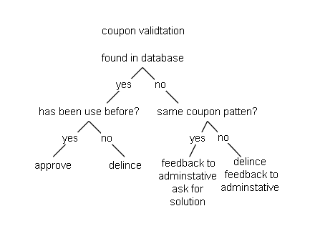

Figure 1. Classification – Simple Decision tree for domino pizza

## References

Brownlee, J. (2019). *Supervised and Unsupervised Machine Learning Algorithms*. [online] Machine Learning Mastery. Available at: https://machinelearningmastery.com/supervised-and-unsupervised-machine-learning-algorithms/ [Accessed 30 Nov. 2019].

Edureka. (2019). *What is Machine Learning? | Types of Machine Learning | Edureka*. [online] Available at: https://www.edureka.co/blog/what-is-machine-learning/ [Accessed 27 Nov. 2019].

Intellipaat Blog. (2019). *Classification in Machine Learning | Supervised Learning | Intellipaat*. [online] Available at: https://intellipaat.com/blog/tutorial/machine-learning-tutorial/classification-machine-learning/ [Accessed 30 Nov. 2019].

Intellipaat Blog. (2019). *Types of Machine Learning - Supervised and Unsupervised - Intellipaat*. [online] Available at: https://intellipaat.com/blog/tutorial/machine-learning-tutorial/types-of-machine-learning/ [Accessed 29 Nov. 2019].

Webopedia.com. (2019). *What is Predictive Analytics? Webopedia Definition*. [online] Available at: https://www.webopedia.com/TERM/P/predictive_analytics.html [Accessed 30 Nov. 2019].